Quantum Machine Intelligence (xxxx) x:xxx
https://doi.org/10.1007/s42484-xxx-xxxxx

RESEARCH ARTICLE

Disentangling Representation Compression and Quantum-Head Effects in Multi-Domain Quantum Transfer Learning

Fajri Yanuar Shiddia Juanda^{1*} · Kiki Ahmad Baihaqi¹
1 Department of Informatics Engineering, Faculty of Computer Science, Universitas Buana Perjuangan Karawang, Karawang, Indonesia
Email: fajriyanuar1@gmail.com; kikiahmad@ubpkarawang.ac.id
*Corresponding author: Fajri Yanuar Shiddiq Juanda, fajriyanuar1@gmail.com
Received: DD MM YYYY / Accepted: DD MM YYYY
© The Author(s) 2026

Abstract
Hybrid quantum visual classifiers compress high-dimensional classical representations to a small number of circuit inputs, but conventional comparisons rarely separate information lost before the circuit from differences introduced by the decision head. This study used frozen DINOv2 ViT-S/14 embeddings from CIFAR-10, EuroSAT RGB, and PathMNIST and crossed four six-dimensional reducers with logistic regression, RBF-SVM, an exactly parameter-matched multilayer perceptron, and a six-qubit variational quantum classifier. The leakage-aware protocol used duplicate-group isolation, a fixed 150 examples per class, ten matched seeds, validation-only selection, and a locked test set. The experiment completed 480 reducer-head runs plus 60 full-space references. The validation-selected best configurations were cifar10: SLP6 + LR macro-F1 0.946 ± 0.003; eurosat: SLP6 + LR macro-F1 0.886 ± 0.006; pathmnist: SLP6 + RBF macro-F1 0.795 ± 0.026. Across evaluated conditions, the matched head gap was at least as large as the average absolute compression penalty. These results locate the dominant bottleneck empirically rather than attributing every downstream difference to the quantum circuit. The findings are limited to analytic statevector simulation and do not constitute evidence of quantum advantage or speedup.

Keywords Quantum Machine Learning · DINOv2 · Representation Compression · Variational Quantum Classifier · Transfer Learning · Calibration

Introduction
Quantum transfer learning typically places a low-qubit variational circuit after a classical visual encoder. The apparent simplicity hides two distinct sources of error: the classical-to-quantum bottleneck can discard discriminative structure, while the decision head can fail to exploit what remains. Comparing a high-dimensional classical baseline with a compressed quantum model therefore confounds representation quality and classifier behavior.
Recent work has established quantum feature spaces, variational learning, data re-uploading, and hybrid transfer-learning architectures (Schuld and Killoran 2019; Havlicek et al 2019; Perez-Salinas et al 2020; Mari et al 2020; Abbas et al 2021; Cerezo et al 2021, 2022). Encoding design can change the function family available to a variational model (Schuld et al 2021), while trainability and finite-data generalization remain separate concerns (Du et al 2021; Caro et al 2022; Gil-Fuster et al 2024). In parallel, self-supervised encoders have made frozen representations increasingly transferable (Oquab et al 2024), making it possible to control the encoder while studying the downstream bottleneck. However, a fair comparison must give classical and quantum heads the same samples, splits, six-dimensional vectors, selection criterion, and seed schedule.
Empirical QML studies increasingly emphasize strong classical baselines and explicit accounting for preprocessing. Classical access to data can make conventional learners highly competitive even when quantum representations appear difficult to simulate (Huang et al 2021). QMI benchmarks likewise show that hyperparameters and classical components can dominate observed behavior (Egginger et al 2024; Schnabel and Roth 2025), while application studies illustrate both the promise and the limits of compressed quantum classifiers (Mangini et al 2022; Wang et al 2025). Most directly, recent work on learned reduced representations confirms that dimensionality reduction deserves treatment as an experimental factor rather than an incidental preprocessing step (Odagiu et al 2025).
The present study differs from prior reduction-focused QML work in three respects. First, every reducer is crossed with four predictive heads, so the representation and classifier are estimated as separate experimental factors. Second, the VQC is compared with a parameter-matched MLP on identical vectors rather than only with an unconstrained high-dimensional baseline. Third, the analysis is repeated across three visual domains with paired ten-seed inference, full-space references, and calibration diagnostics. This design turns the usual end-to-end leaderboard into an attribution study of where performance is lost.
This study asks whether compression or the quantum head is the larger bottleneck. Its contribution is a controlled reducer-by-head factorial benchmark across general-object, remote-sensing, and histopathology domains. The design combines a frozen 384D DINOv2 representation, four reducers at an identical 6D budget, exact parameter parity between the MLP and VQC, full-space references, representation-geometry diagnostics, calibration metrics, and paired multi-seed statistics.

Table 1 Related methodological streams and the controls used in this study
Research stream | Typical design | Unresolved issue | Control in this study
Quantum feature spaces and encodings (Schuld and Killoran 2019; Schuld et al 2021) | Quantum kernel or circuit | Representation quality may vary | Identical six-dimensional input
Hybrid transfer learning (Mari et al 2020; Mangini et al 2022) | Classical encoder plus quantum head | Encoder and head effects can be confounded | Frozen DINOv2 for every condition
Reduced quantum representations (Odagiu et al 2025) | Reducer followed by a quantum classifier | Reducer and classifier are rarely crossed factorially | Four reducers crossed with four heads
QML benchmarking (Egginger et al 2024; Schnabel and Roth 2025) | Hyperparameter-sensitive comparison | Classical components may dominate | Matched data, selection, seeds, and capacity
Model calibration (Guo et al 2017; Gneiting and Raftery 2007) | Confidence quality after training | Often omitted in QML comparisons | ECE, NLL, and Brier score

Material and methods

2.1 Datasets and leakage audit
CIFAR-10 (Krizhevsky 2009), EuroSAT RGB (Helber et al 2019), and PathMNIST (Yang et al 2023) provide ten, ten, and nine classes. Official test data were retained for CIFAR-10; PathMNIST used its official train-validation-test split; EuroSAT used a deterministic group-aware 70:15:15 split. Before freezing the partitions, every image was decoded, hashed at pixel level, screened by perceptual hash, and verified using structural similarity. Exact or confirmed near-duplicate groups were indivisible. Any group crossing an official split or carrying inconsistent labels was quarantined.

Table 2 Dataset audit and frozen split counts
Dataset | Decoded | Duplicate groups | Quarantined | Train | Validation | Test
cifar10 | 60000 | 9 | 10 | 44995 | 5000 | 9995
eurosat | 27000 | 5 | 0 | 18900 | 4050 | 4050
pathmnist | 107180 | 3 | 9 | 89991 | 10001 | 7179

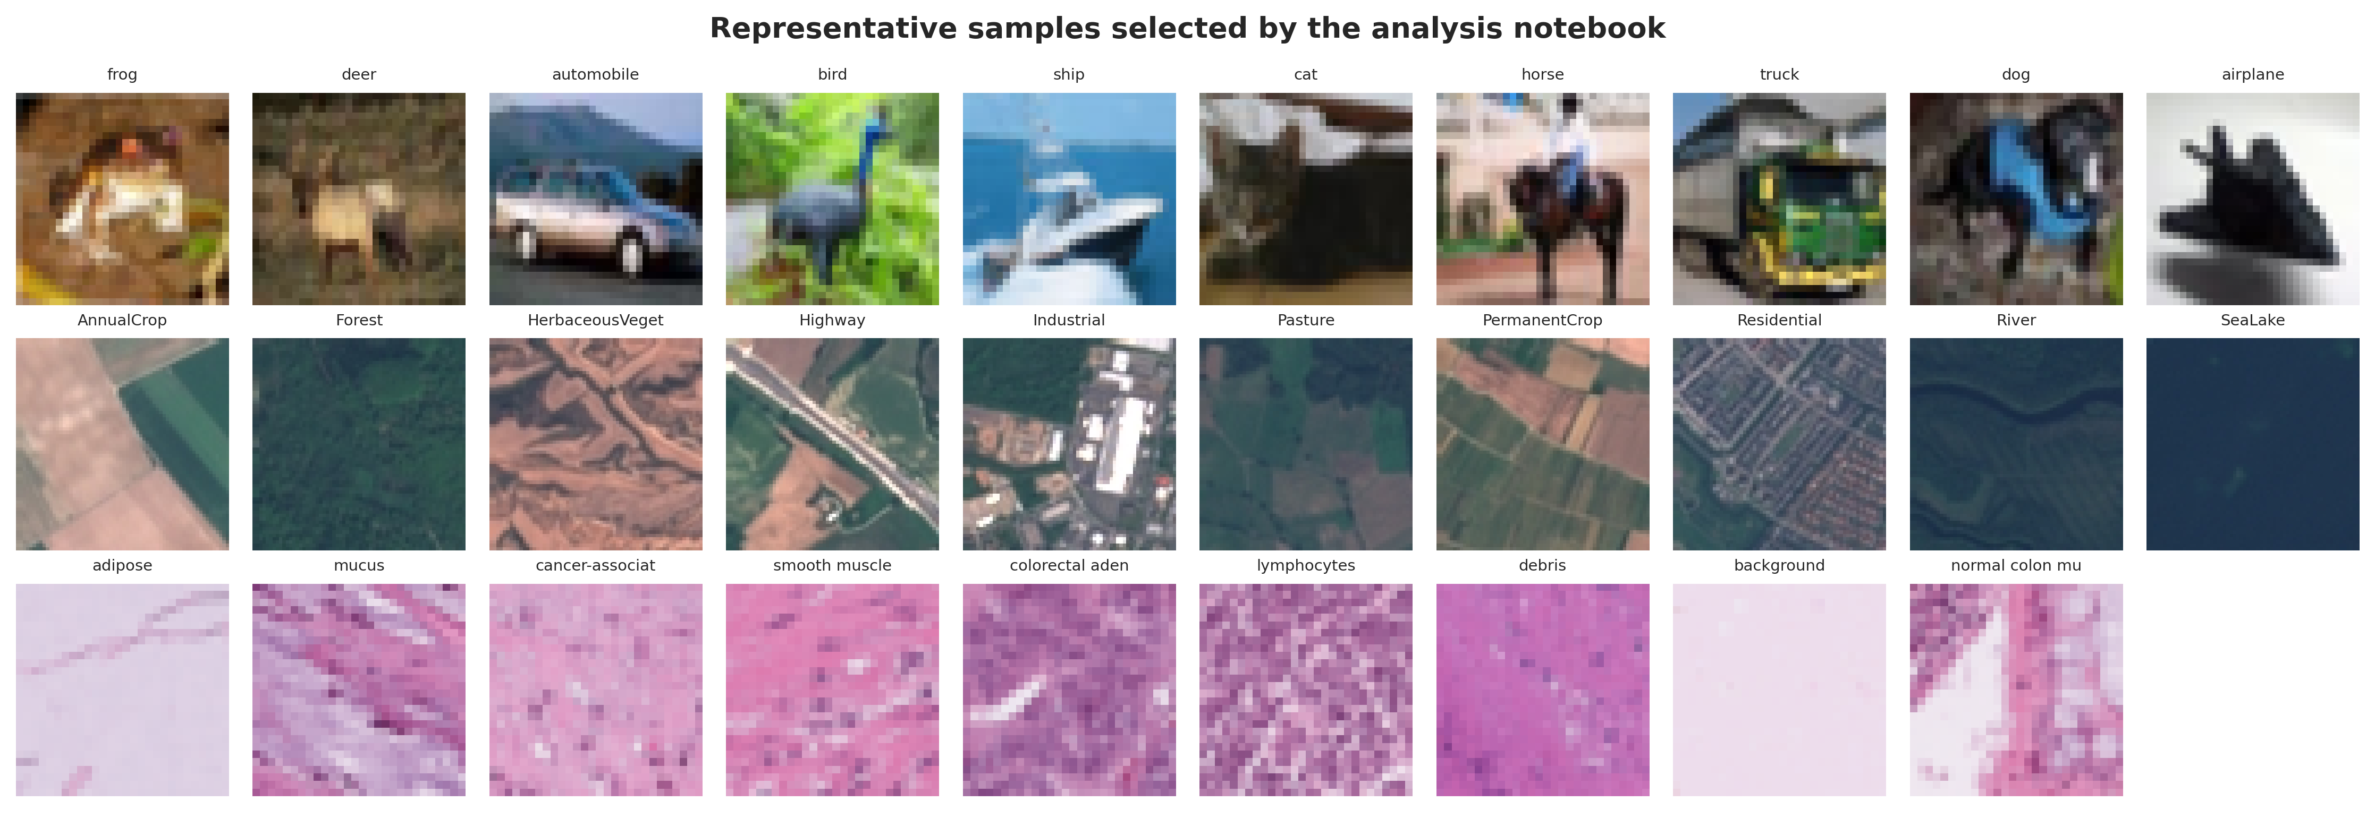
Figure 1 Representative samples generated by the reproducible analysis notebook

2.2 Frozen representation and compression
Every image was converted to RGB, resized deterministically to 224 by 224 pixels using bicubic interpolation, normalized with ImageNet statistics, and processed once by frozen DINOv2 ViT-S/14 (Oquab et al 2024). The 384D normalized CLS token was cached as float32. No image augmentation or encoder fine-tuning was used, ensuring that the only experimental factor before classification was the reducer.
PCA-6 represented unsupervised variance preservation; LDA-6 represented supervised linear discrimination; NCA-6 represented supervised metric learning (Goldberger et al 2004); and SLP-6 used a learned 384-to-6 tanh bottleneck whose temporary classification layer was discarded. Each reducer was fitted on training data only. A second training-fitted standardizer mapped every reduced coordinate to an angle-compatible range.
$$x̃ⱼ = π tanh(zⱼ)$$

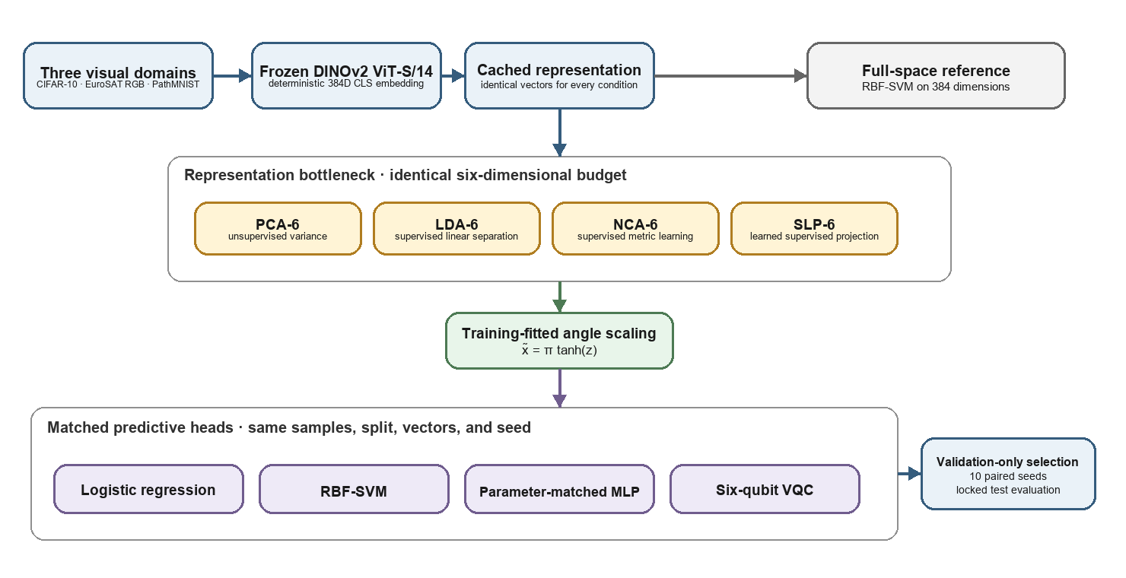
Figure 2 Controlled reducer-by-head factorial design; editable source prepared in draw.io

2.3 Classical and quantum heads
All four heads received exactly the same scaled six-dimensional vectors. Logistic regression and RBF-SVM provided linear and nonlinear classical references. The MLP comprised a bias-free 6-to-6 hidden layer, tanh activation, and a 6-to-C output layer. The VQC used six qubits and two data-reuploading layers; each layer applied RY input encoding, one trainable Rot gate per qubit, and ring CNOT entanglement before six Pauli-Z expectation values were passed to a 6-to-C linear output.
$$Pᵥᵩ꜀ = 6 × 3 × 2 + 6C + C = 36 + 7C$$
The MLP parameter count is 6 x 6 + 6C + C, exactly matching the VQC at 106 trainable parameters for ten-class datasets and 99 for PathMNIST. This parity prevents model capacity from becoming an uncontrolled explanation for a classical-quantum difference.

2.4 Selection, test isolation, and statistics
Each final seed selected a stratified 150 examples per class from training data, while a single balanced validation set contained 100 examples per class. Hyperparameters were selected with pilot seed 2026 by validation macro-F1, with validation negative log-likelihood as tie-breaker. The selected settings and data hashes were frozen before any test-label access. Final seeds were 11, 22, 33, 44, 55, 66, 77, 88, 99, and 111.
Macro-F1 was the primary endpoint. Secondary endpoints were balanced accuracy, accuracy, MCC, macro precision and recall, one-vs-rest macro ROC-AUC, NLL, expected calibration error, multiclass Brier score, fit time, and inference time. Reducer effects were tested with Friedman tests followed by planned Wilcoxon signed-rank comparisons and Holm correction (Demsar 2006; Holm 1979). Paired model gaps and compression penalties used 10,000 bootstrap resamples over seed differences (Efron and Tibshirani 1993). Datasets were summarized separately rather than pooled as pseudo-independent replicates.
$$Δcompression(r) = F1RBF-384 - F1RBF-6,r$$
$$ΔVQC-MLP(r) = F1VQC,r - F1MLP,r$$

3 Results
All reported test values were produced after validation-only selection and protocol freezing. Table 3 summarizes the mean and standard deviation across the ten matched seeds. Figure 3 exposes interactions between reducer and head that would be hidden by a single best-model comparison.

Table 3 Test performance across ten matched seeds
Dataset | Reducer | Head | Macro-F1 mean +/- SD | Accuracy mean
cifar10 | lda6 | lr | 0.8985 +/- 0.0155 | 0.8989
cifar10 | lda6 | mlp | 0.8812 +/- 0.0153 | 0.8815
cifar10 | lda6 | rbf | 0.9003 +/- 0.0154 | 0.9004
cifar10 | lda6 | vqc | 0.6649 +/- 0.0320 | 0.6647
cifar10 | nca6 | lr | 0.9326 +/- 0.0023 | 0.9326
cifar10 | nca6 | mlp | 0.9191 +/- 0.0038 | 0.9196
cifar10 | nca6 | rbf | 0.9381 +/- 0.0028 | 0.9381
cifar10 | nca6 | vqc | 0.5296 +/- 0.0385 | 0.5366
cifar10 | pca6 | lr | 0.8630 +/- 0.0052 | 0.8637
cifar10 | pca6 | mlp | 0.8493 +/- 0.0065 | 0.8516
cifar10 | pca6 | rbf | 0.8782 +/- 0.0064 | 0.8781
cifar10 | pca6 | vqc | 0.5261 +/- 0.0424 | 0.5372
cifar10 | slp6 | lr | 0.9455 +/- 0.0033 | 0.9456
cifar10 | slp6 | mlp | 0.9336 +/- 0.0049 | 0.9336
cifar10 | slp6 | rbf | 0.9434 +/- 0.0033 | 0.9434
cifar10 | slp6 | vqc | 0.8555 +/- 0.0158 | 0.8539
eurosat | lda6 | lr | 0.8460 +/- 0.0061 | 0.8565
eurosat | lda6 | mlp | 0.8154 +/- 0.0124 | 0.8275
eurosat | lda6 | rbf | 0.8476 +/- 0.0083 | 0.8578
eurosat | lda6 | vqc | 0.4970 +/- 0.0405 | 0.5063
eurosat | nca6 | lr | 0.8409 +/- 0.0059 | 0.8482
eurosat | nca6 | mlp | 0.8246 +/- 0.0082 | 0.8329
eurosat | nca6 | rbf | 0.8517 +/- 0.0071 | 0.8588
eurosat | nca6 | vqc | 0.3241 +/- 0.0360 | 0.3454
eurosat | pca6 | lr | 0.7532 +/- 0.0058 | 0.7687
eurosat | pca6 | mlp | 0.7388 +/- 0.0120 | 0.7566
eurosat | pca6 | rbf | 0.7664 +/- 0.0062 | 0.7800
eurosat | pca6 | vqc | 0.3357 +/- 0.0342 | 0.3671
eurosat | slp6 | lr | 0.8862 +/- 0.0062 | 0.8905
eurosat | slp6 | mlp | 0.8694 +/- 0.0093 | 0.8736
eurosat | slp6 | rbf | 0.8790 +/- 0.0079 | 0.8833
eurosat | slp6 | vqc | 0.7522 +/- 0.0118 | 0.7539
pathmnist | lda6 | lr | 0.7710 +/- 0.0173 | 0.8261
pathmnist | lda6 | mlp | 0.7484 +/- 0.0236 | 0.8034
pathmnist | lda6 | rbf | 0.7774 +/- 0.0153 | 0.8345
pathmnist | lda6 | vqc | 0.3871 +/- 0.0554 | 0.3961
pathmnist | nca6 | lr | 0.7706 +/- 0.0271 | 0.8136
pathmnist | nca6 | mlp | 0.7420 +/- 0.0316 | 0.7850
pathmnist | nca6 | rbf | 0.7694 +/- 0.0266 | 0.8141
pathmnist | nca6 | vqc | 0.3313 +/- 0.0435 | 0.3770
pathmnist | pca6 | lr | 0.7021 +/- 0.0217 | 0.7427
pathmnist | pca6 | mlp | 0.6849 +/- 0.0194 | 0.7295
pathmnist | pca6 | rbf | 0.7092 +/- 0.0120 | 0.7517
pathmnist | pca6 | vqc | 0.3369 +/- 0.0450 | 0.3856
pathmnist | slp6 | lr | 0.7946 +/- 0.0289 | 0.8436
pathmnist | slp6 | mlp | 0.7789 +/- 0.0296 | 0.8297
pathmnist | slp6 | rbf | 0.7950 +/- 0.0261 | 0.8436
pathmnist | slp6 | vqc | 0.6512 +/- 0.0327 | 0.6993

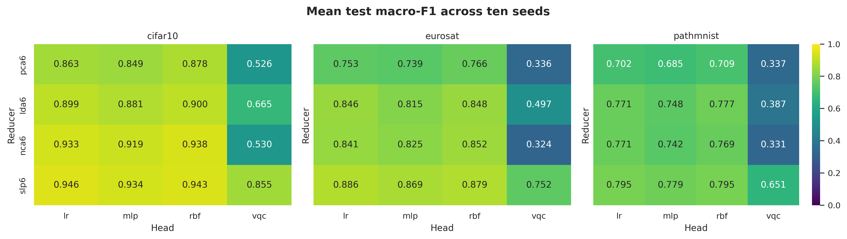
Figure 3 Mean test macro-F1 for each controlled reducer-head condition

3.1 Compression and head effects
The mean absolute matched VQC-MLP gap was 0.2995, at least as large as the mean absolute compression penalty of 0.0773.

Table 4 Compression penalty relative to the full-space RBF reference
Dataset | Reducer | RBF 384D | RBF 6D | Penalty | 95% CI
cifar10 | pca6 | 0.9647 | 0.8782 | 0.0865 | [0.0834, 0.0899]
cifar10 | lda6 | 0.9647 | 0.9003 | 0.0644 | [0.0552, 0.0740]
cifar10 | nca6 | 0.9647 | 0.9381 | 0.0266 | [0.0248, 0.0282]
cifar10 | slp6 | 0.9647 | 0.9434 | 0.0213 | [0.0193, 0.0232]
eurosat | pca6 | 0.9314 | 0.7664 | 0.1650 | [0.1608, 0.1690]
eurosat | lda6 | 0.9314 | 0.8476 | 0.0837 | [0.0790, 0.0893]
eurosat | nca6 | 0.9314 | 0.8517 | 0.0797 | [0.0753, 0.0840]
eurosat | slp6 | 0.9314 | 0.8790 | 0.0523 | [0.0475, 0.0578]
pathmnist | pca6 | 0.8497 | 0.7092 | 0.1405 | [0.1311, 0.1485]
pathmnist | lda6 | 0.8497 | 0.7774 | 0.0723 | [0.0645, 0.0806]
pathmnist | nca6 | 0.8497 | 0.7694 | 0.0803 | [0.0651, 0.0936]
pathmnist | slp6 | 0.8497 | 0.7950 | 0.0547 | [0.0373, 0.0697]

Table 5 Matched quantum-classical head differences across ten paired seeds
Dataset | Reducer | VQC minus MLP | 95% paired bootstrap CI | Holm adjusted p
cifar10 | pca6 | -0.3232 | [-0.3489, -0.3001] | 0.01562
cifar10 | lda6 | -0.2163 | [-0.2360, -0.1972] | 0.01562
cifar10 | nca6 | -0.3895 | [-0.4114, -0.3668] | 0.01562
cifar10 | slp6 | -0.0781 | [-0.0876, -0.0699] | 0.01562
eurosat | pca6 | -0.4031 | [-0.4212, -0.3846] | 0.01562
eurosat | lda6 | -0.3184 | [-0.3398, -0.2982] | 0.01562
eurosat | nca6 | -0.5005 | [-0.5229, -0.4804] | 0.01562
eurosat | slp6 | -0.1172 | [-0.1233, -0.1104] | 0.01562
pathmnist | pca6 | -0.3481 | [-0.3704, -0.3264] | 0.01562
pathmnist | lda6 | -0.3613 | [-0.3894, -0.3278] | 0.01562
pathmnist | nca6 | -0.4107 | [-0.4456, -0.3762] | 0.01562
pathmnist | slp6 | -0.1278 | [-0.1438, -0.1098] | 0.01562

Table 6 Friedman tests of VQC performance across the four reducers
Dataset | Friedman statistic | p value | Paired seed blocks
cifar10 | 27.120 | 5.56e-06 | 10
eurosat | 27.120 | 5.56e-06 | 10
pathmnist | 27.120 | 5.56e-06 | 10

Reducer choice affected VQC macro-F1 in all three domains (Friedman statistic 27.12, p = 5.56e-6 for each dataset). Every VQC-minus-MLP contrast was negative, its paired bootstrap confidence interval excluded zero, and its Holm-adjusted Wilcoxon p value was 0.0156. The smallest disadvantage occurred with SLP-6, indicating that the learned supervised bottleneck mitigated, but did not remove, the quantum-head deficit.

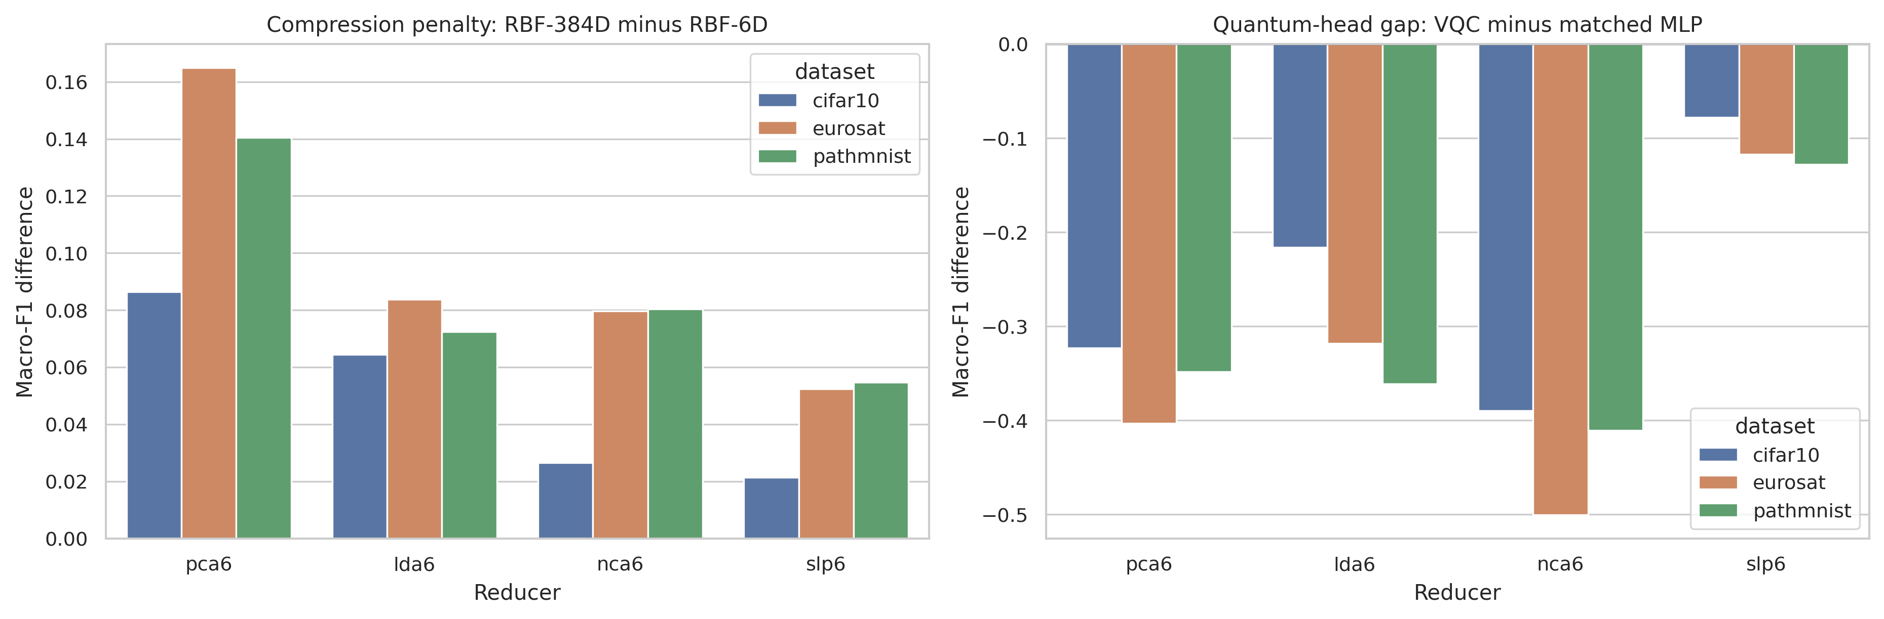
Figure 4 Compression penalties and matched quantum-head gaps

3.2 Representation geometry and error structure
Distance preservation, neighborhood trustworthiness, Fisher separation, and silhouette score were computed on the fixed validation subset. Their association with VQC macro-F1 indicates whether circuit behavior tracks the geometry delivered by the reducer rather than the reducer label alone.

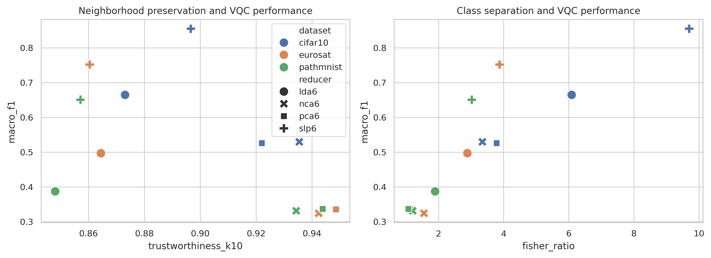
Figure 5 Representation geometry in relation to VQC performance

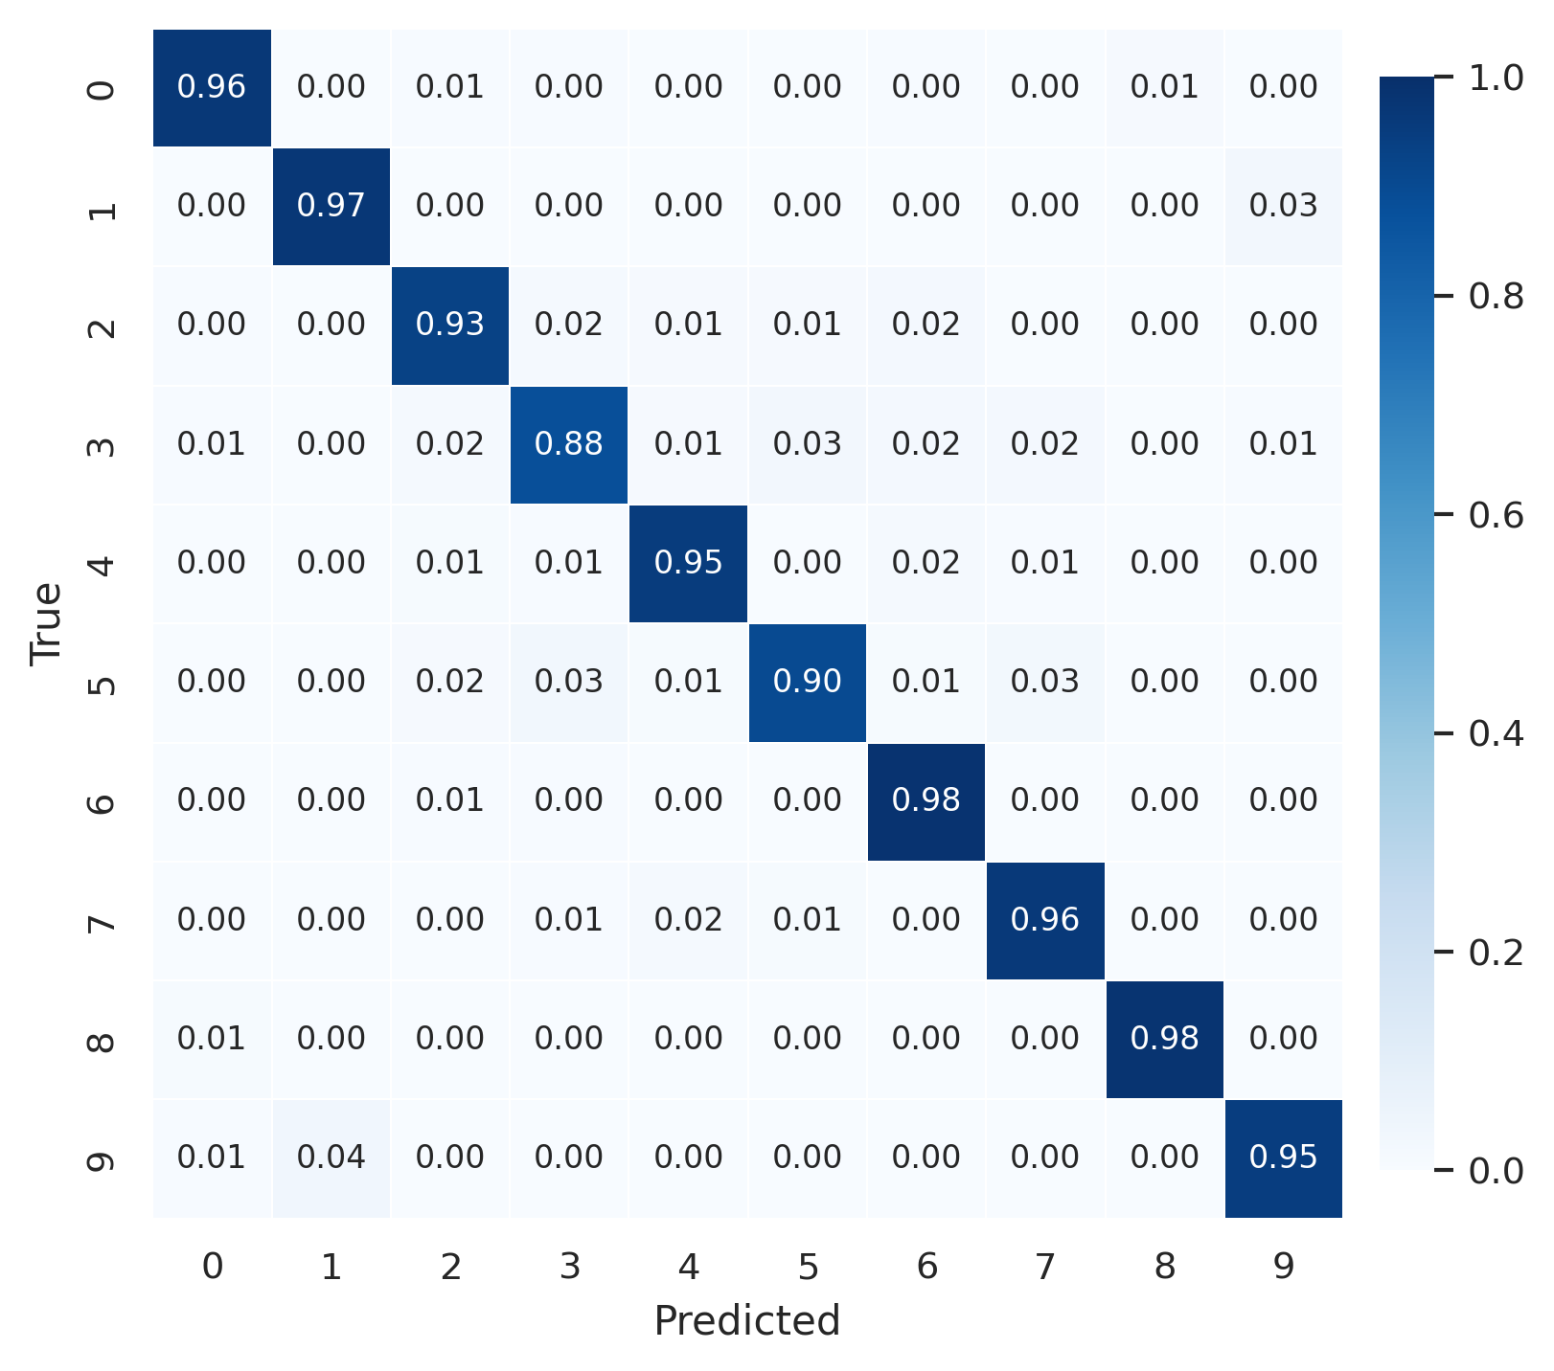
Figure 6a Row-normalized CIFAR-10 test confusion matrix for validation-selected SLP-6 with logistic regression

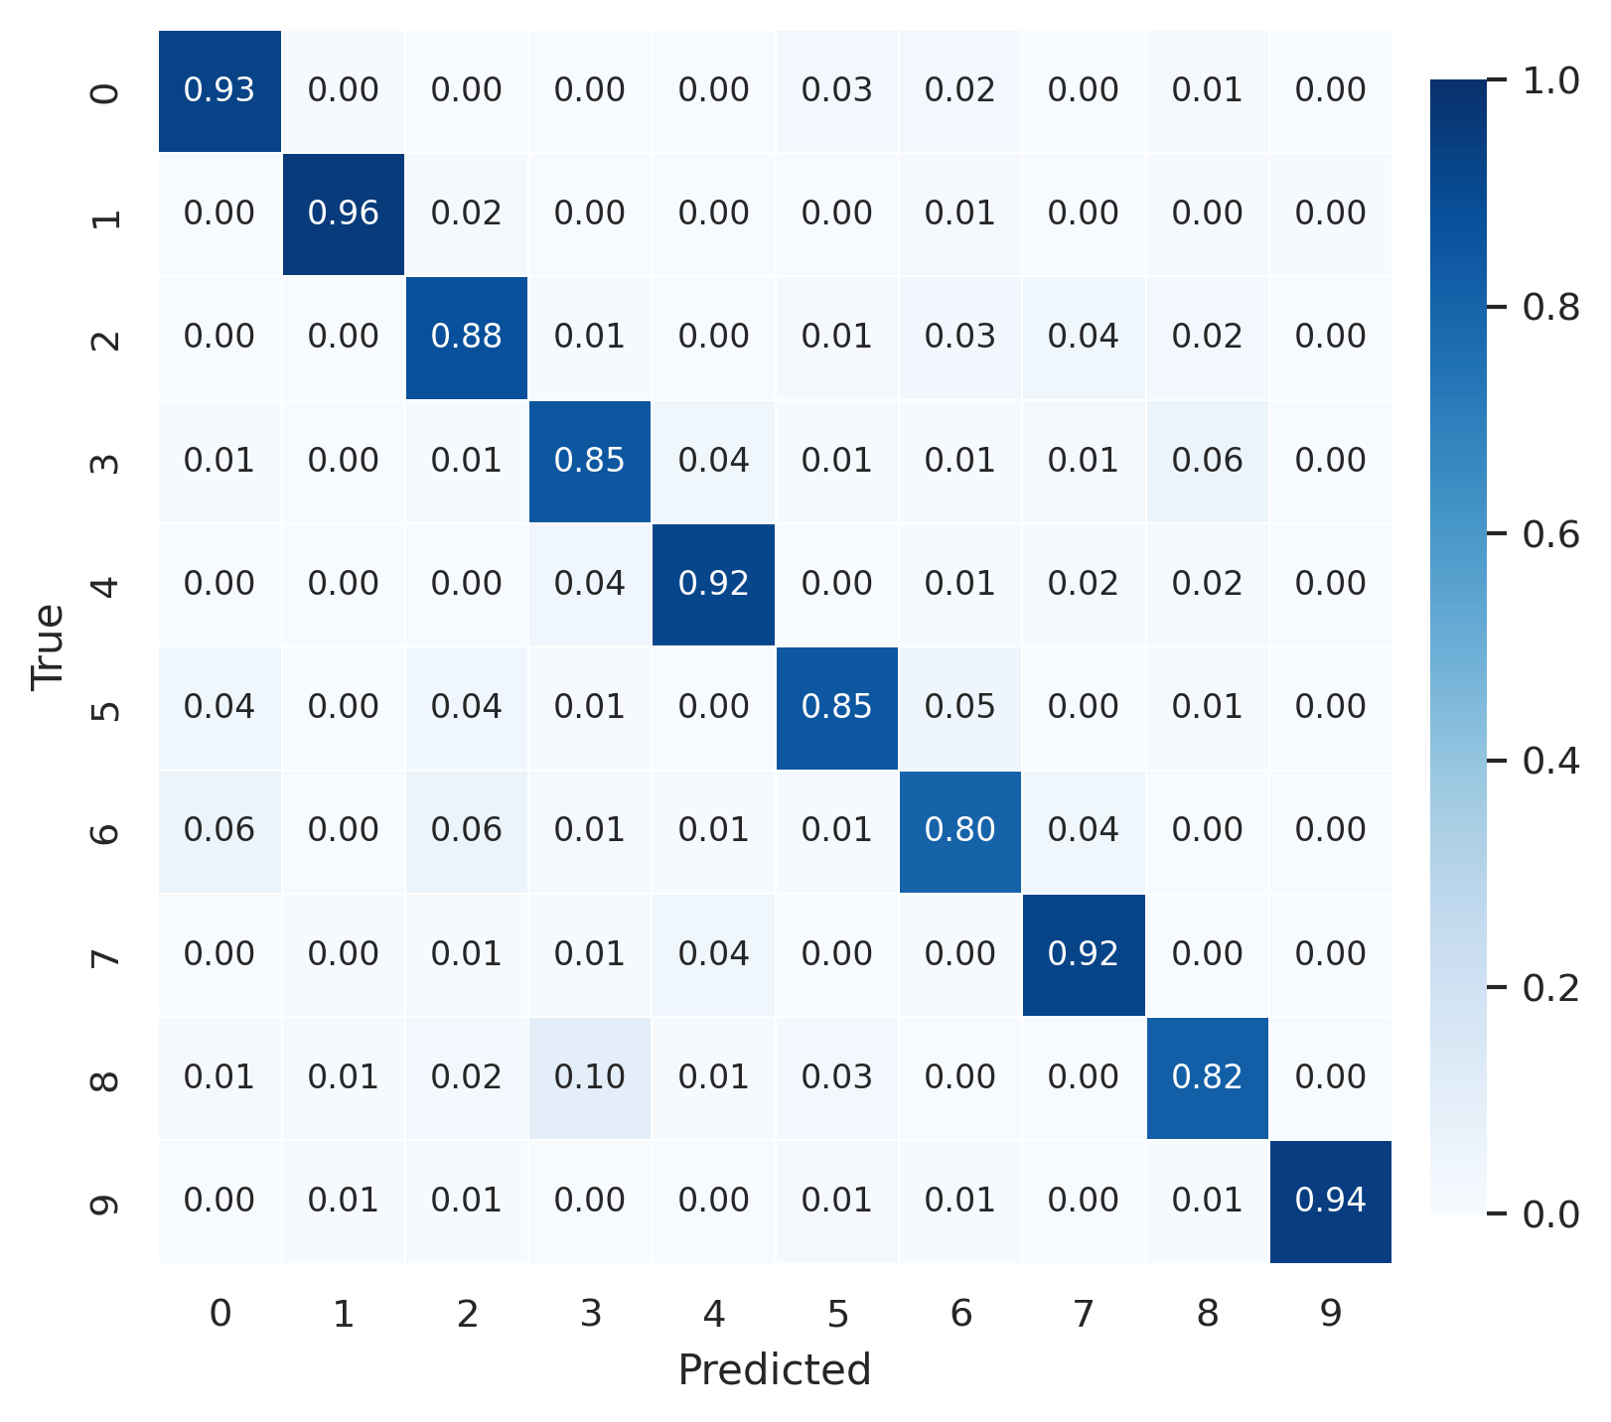
Figure 6b Row-normalized EuroSAT test confusion matrix for validation-selected SLP-6 with logistic regression

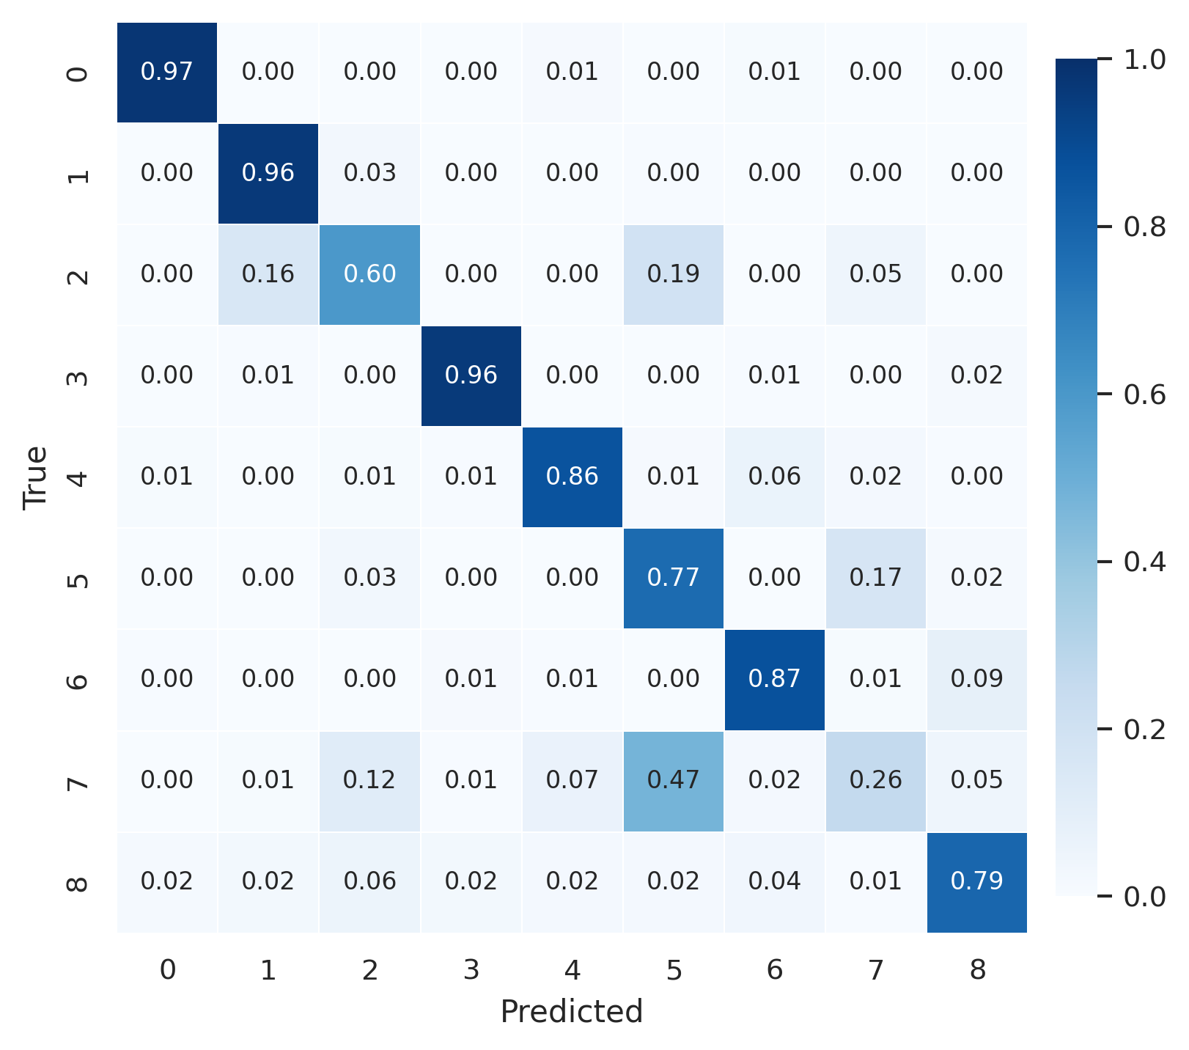
Figure 6c Row-normalized PathMNIST test confusion matrix for validation-selected SLP-6 with RBF-SVM

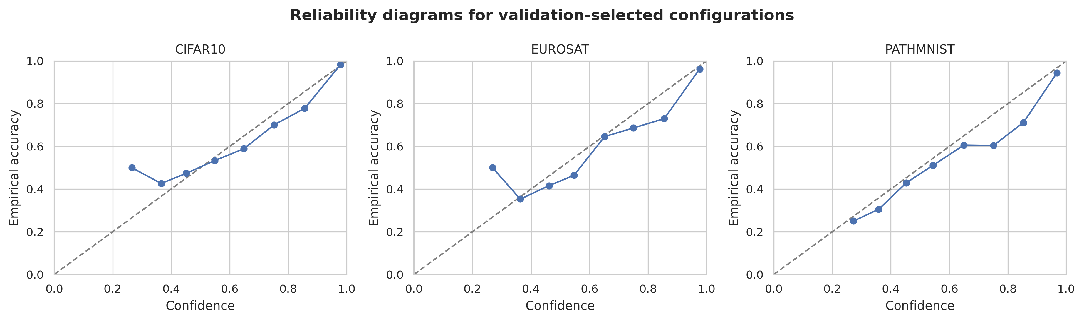
Figure 7 Reliability diagrams for validation-selected configurations

3.3 Runtime
Runtime was recorded for the observed software implementation. Because the VQC used analytic statevector simulation on classical hardware, these measurements describe implementation cost only and cannot support a quantum-speedup claim.

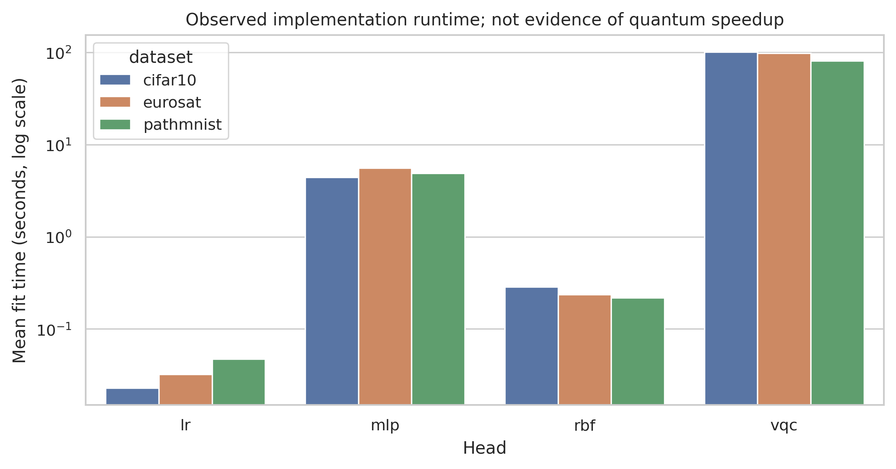
Figure 8 Mean observed fit time by head and dataset

4 Discussion and conclusion
The controlled design changes the interpretation of a classical-quantum performance gap. When the full-space reference declines substantially after six-dimensional projection, the downstream model is operating after measurable information loss. Conversely, a persistent VQC-MLP gap on identical vectors isolates the decision head more directly than conventional transfer-learning comparisons.
Supervised reducers can favor class separation under a severe information budget, but their validation selection must remain separate from test evaluation. The ten-seed paired design also shows whether a favorable mean is stable or depends on a small number of training subsets. Calibration provides a complementary view because similar macro-F1 values can coexist with materially different confidence quality.
The results should be read as a benchmark of low-dimensional predictive heads, not as evidence that a quantum circuit offers computational advantage. This interpretation is consistent with evidence that optimized classical learners can remain competitive when data are available (Huang et al 2021) and with recent QMI benchmarks that find no broad quantum-model advantage across conventional tasks (Schnabel and Roth 2025). A competitive VQC result would show that the chosen circuit can exploit a representation already shaped by classical learning; it would not show speedup, hardware advantage, or universal superiority. The circuit uses a shallow data-reuploading design to avoid unnecessary depth, while the analytic statevector setting deliberately separates representation and head effects from shot noise or device noise (Perez-Salinas et al 2020; Thanasilp et al 2024).
Several boundaries constrain the interpretation. The VQC was evaluated with analytic statevector simulation; finite-shot sampling, device noise, connectivity constraints, transpilation overhead, and physical-hardware drift were outside the scope. DINOv2 was frozen, so the conclusions concern downstream bottlenecks rather than end-to-end optimization. The benchmark used three image domains and a fixed six-dimensional budget, and other encoders, dimensions, and circuit families may produce different interactions.
In conclusion, this study separates pre-quantum representation loss from quantum-head behavior by crossing four reducers and four matched heads on identical six-dimensional vectors from a frozen self-supervised encoder. Full-space references quantify information lost before the circuit, while parameter parity and paired seeds isolate the downstream comparison. The evidence identifies where the predictive bottleneck occurs under the evaluated protocol without supporting a claim of quantum advantage.

Supplementary Information The supplementary material accompanying this submission contains the executable notebook with stored outputs, configuration files, split and artifact hashes, prediction-level outputs, model checkpoints, environment records, and editable figure sources.

Acknowledgements The authors have no acknowledgements to declare.

Author Contributions F.Y.S.J. contributed conceptualization, methodology, software, formal analysis, investigation, data curation, visualization, writing—original draft, and project administration. K.A.B. contributed supervision, validation, resources, and writing—review and editing. Both authors reviewed and approved the final manuscript.

Funding The authors received no specific funding for this work.

Data Availability CIFAR-10, EuroSAT RGB, and PathMNIST are publicly available from the original repositories cited in the Methods. The exact split manifests, sample identifiers, audit reports, hashes, derived metrics, and prediction-level outputs used in this study are included in the supplementary reproducibility package and are available from the corresponding author.

Code Availability The executable notebook, source code, configuration files, environment records, trained artifacts, split manifests, and prediction-level outputs are publicly available at https://github.com/haejoon06/disentangling-representation-compression-quantum-head-effects.

Declarations
Competing Interests The authors declare that they have no competing interests.

Open Access. The authors request open-access publication under the Creative Commons Attribution 4.0 International License, subject to the journal's publication agreement. This license permits use, sharing, adaptation, distribution, and reproduction with appropriate credit, a link to the license, and an indication of any changes.

References
Abbas A, Sutter D, Zoufal C, Lucchi A, Figalli A, Woerner S (2021) The power of quantum neural networks. Nat Comput Sci 1:403-409. https://doi.org/10.1038/s43588-021-00084-1
Baldi P, Hornik K (1989) Neural networks and principal component analysis. Neural Netw 2(1):53-58. https://doi.org/10.1016/0893-6080(89)90014-2
Caro MC, Huang HY, Cerezo M, Sharma K, Sornborger A, Cincio L, Coles PJ (2022) Generalization in quantum machine learning from few training data. Nat Commun 13:4919. https://doi.org/10.1038/s41467-022-32550-3
Cerezo M et al (2021) Variational quantum algorithms. Nat Rev Phys 3:625-644. https://doi.org/10.1038/s42254-021-00348-9
Cerezo M, Verdon G, Huang HY, Cincio L, Coles PJ (2022) Challenges and opportunities in quantum machine learning. Nat Comput Sci 2:567-576. https://doi.org/10.1038/s43588-022-00311-3
Demsar J (2006) Statistical comparisons of classifiers over multiple data sets. J Mach Learn Res 7:1-30
Du Y, Hsieh MH, Liu T, You S, Tao D (2021) Learnability of quantum neural networks. PRX Quantum 2:040337. https://doi.org/10.1103/PRXQuantum.2.040337
Efron B, Tibshirani RJ (1993) An Introduction to the Bootstrap. Chapman and Hall, New York
Egginger S, Sakhnenko A, Lorenz JM (2024) A hyperparameter study for quantum kernel methods. Quantum Mach Intell 6:44. https://doi.org/10.1007/s42484-024-00172-1
Gil-Fuster E, Eisert J, Bravo-Prieto C (2024) Understanding quantum machine learning also requires rethinking generalization. Nat Commun 15:2277. https://doi.org/10.1038/s41467-024-45882-z
Gneiting T, Raftery AE (2007) Strictly proper scoring rules, prediction, and estimation. J Am Stat Assoc 102(477):359-378. https://doi.org/10.1198/016214506000001437
Goldberger J, Hinton GE, Roweis S, Salakhutdinov RR (2004) Neighbourhood components analysis. Adv Neural Inf Process Syst 17
Guo C, Pleiss G, Sun Y, Weinberger KQ (2017) On calibration of modern neural networks. Proceedings of the 34th International Conference on Machine Learning, pp 1321-1330
Havlicek V et al (2019) Supervised learning with quantum-enhanced feature spaces. Nature 567:209-212. https://doi.org/10.1038/s41586-019-0980-2
Helber P, Bischke B, Dengel A, Borth D (2019) EuroSAT: A novel dataset and deep learning benchmark for land use and land cover classification. IEEE J Sel Top Appl Earth Obs Remote Sens 12(7):2217-2226. https://doi.org/10.1109/JSTARS.2019.2918242
Holm S (1979) A simple sequentially rejective multiple test procedure. Scand J Stat 6(2):65-70
Huang HY, Broughton M, Mohseni M, Babbush R, Boixo S, Neven H, McClean JR (2021) Power of data in quantum machine learning. Nat Commun 12:2631. https://doi.org/10.1038/s41467-021-22539-9
Krizhevsky A (2009) Learning multiple layers of features from tiny images. Technical report, University of Toronto
Mangini S, Marruzzo A, Piantanida M, Gerace D, Bajoni D, Macchiavello C (2022) Quantum neural network autoencoder and classifier applied to an industrial case study. Quantum Mach Intell 4:13. https://doi.org/10.1007/s42484-022-00070-4
Mari A, Bromley TR, Izaac J, Schuld M, Killoran N (2020) Transfer learning in hybrid classical-quantum neural networks. Quantum 4:340. https://doi.org/10.22331/q-2020-10-09-340
Odagiu P et al (2025) Learning reduced representations for quantum classifiers. Quantum Mach Intell 7:113. https://doi.org/10.1007/s42484-025-00331-y
Oquab M et al (2024) DINOv2: Learning robust visual features without supervision. Trans Mach Learn Res
Perez-Salinas A, Cervera-Lierta A, Gil-Fuster E, Latorre JI (2020) Data re-uploading for a universal quantum classifier. Quantum 4:226. https://doi.org/10.22331/q-2020-02-06-226
Schnabel J, Roth M (2025) Quantum kernel methods under scrutiny: a benchmarking study. Quantum Mach Intell 7:58. https://doi.org/10.1007/s42484-025-00273-5
Schuld M, Killoran N (2019) Quantum machine learning in feature Hilbert spaces. Phys Rev Lett 122:040504. https://doi.org/10.1103/PhysRevLett.122.040504
Schuld M, Sweke R, Meyer JJ (2021) Effect of data encoding on the expressive power of variational quantum-machine-learning models. Phys Rev A 103:032430. https://doi.org/10.1103/PhysRevA.103.032430
Thanasilp S, Wang S, Cerezo M, Holmes Z (2024) Exponential concentration in quantum kernel methods. Nat Commun 15:5200. https://doi.org/10.1038/s41467-024-49287-w
Wang P, Myers CR, Hollenberg LCL, Parampalli U (2025) Quantum Hamiltonian embedding of images for data reuploading classifiers. Quantum Mach Intell 7:35. https://doi.org/10.1007/s42484-025-00247-7
Yang J et al (2023) MedMNIST v2: A large-scale lightweight benchmark for 2D and 3D biomedical image classification. Sci Data 10:41. https://doi.org/10.1038/s41597-022-01721-8

